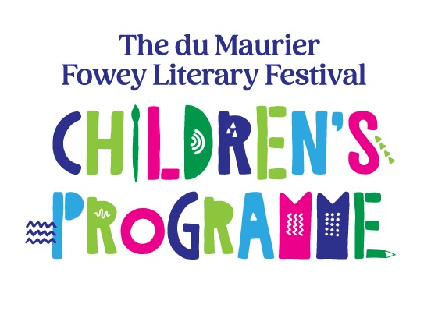
Competition for Young Writers and Artists 2025 - Individual Entry Form

Please check the Competition Rules on our website at www.foweyfestival.com Entry is open and free to young writers and artists from 4 to 16 years of age on 31st August 2025 who live in Cornwall & Isles of Scilly.
Complete this form (one form per entry) and enclose it with your poem, story, piece of factual writing or picture with the title ‘Making Waves!’
Write the entrant’s name, age and year group, legibly, on the back of each entry.
Address the form to:
The du Maurier Fowey Literary Festival Competition for Young Writers and Artists.
Either post it to: 50 Tower Park, Fowey, PL23 1JD or drop it into Fowey River Gallery, 38 Fore Street, Fowey, Cornwall PL23 1AQ, on Monday to Saturday between 10am and 5pm.
Entries must arrive by 5pm Wednesday 5th March 2025. Entry is free.
NAME:
ADDRESS:
MY POEM, STORY, PIECE OF FACTUAL WRITING OR PICTURE (PLEASE UNDERLINE WHICH) IS ALL MY OWN WORK, OR I HAVE NOTED ANY HELP GIVEN. IT HAS NOT BEEN PREVIOUSLY PUBLISHED, BROADCAST OR DISPLAYED IN PUBLIC.
Signed: Date:

SCHOOL CATEGORY: FS/KS1 KS2 KS3/KS4 (Please underline one) Age 4–7 Age 7–11 Age 11 – 16

SCHOOL YEAR: AGE:
ANY ADDITIONAL NEEDS requiring 1:1 support (Y=yes) to inform judges:

(Parent/Guardian or School details as appropriate below)
NAME:
DAYTIME TELEPHONE NUMBER
EMAIL ADDRESS:

