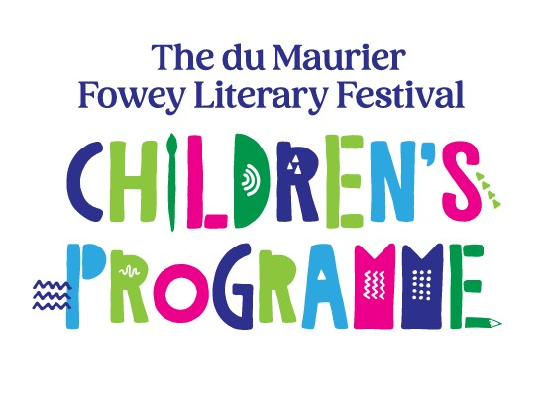

Competition for Young Writers and Artists 2025 – Group Entry Form
Please check the Competition Rules on our website at www.foweyfestival.com
Entry is open to young writers and artists from 4 to 16 years of age on 31st August 2025, who live in Cornwall & Isles of Scilly.
List the pupils’ names in year groups on the form below. Please indicate whether the work was done unaided as a ‘cold’ write or supported by teaching in school. Please also note any pupils who have additional support because they have additional needs.
Write pupils’ name and Year Group legibly on the back of each entry.
Send forms and entries to: The du Maurier Fowey Literary Festival Competition for Young Writers and Artists, 50 Tower Park, Fowey, PL23 1JD; deliver them to Fowey River Gallery, 38 Fore Street, Fowey, Cornwall PL23 1AQ (Monday to Saturday between 10am and 5pm), or email to angela@foweyfestival.com
All entries must arrive by 5pm Wednesday 5th March 2025. Entry is free.

School Name:
ADDRESS:

SCHOOL CATEGORY: FS/KS1 KS2 KS3/4 (Please underline one) Age 4–7 Age 7–11 Age 11 – 16
TEACHER’S NAME:
TEACHER’S CONTACT NUMBER:
TEACHER’S EMAIL ADDRESS:
Total no. of entries: Poems: Stories: Factual writing: Pictures:
The poems, stories, factual writing and pictures I have entered have not been previously published, broadcast or publicly displayed and are the pupils’ own work, or help given is noted on the form.
Signed: Date:

School:

List entries in Year Groups.

Year Group | Pupil’s Name (only | Age | Poem P  Story S  Factual F  Art A | Pupil with additional needs SEN requiring 1:1 support: SEN and any details you wish to give. | (admin use only)

